**Modules**

1.Patients

2.consultants

3.Forum/Questions

4. consultations/chats

5.Prescriptions history and Notes

6.Health Tools

7. Appointments

8. Pakages

9.Lab

10. Pharmacy

11.Finance

Adding patients

Name, Phone number,Email,username,password,Age, Date of birth, Gender,Country,city,town

adding a consultant:

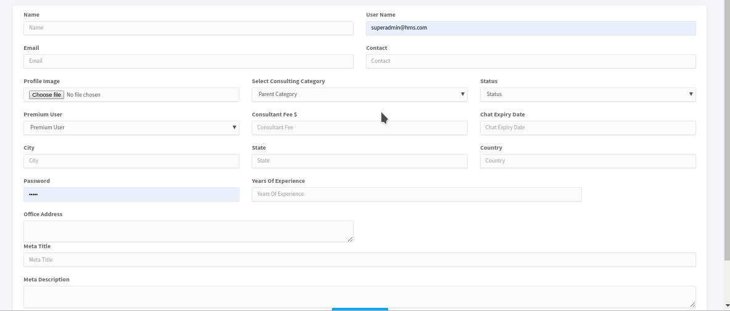

Schedules

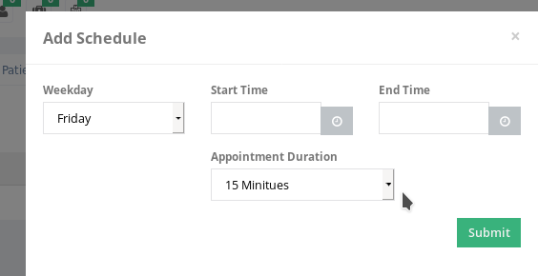

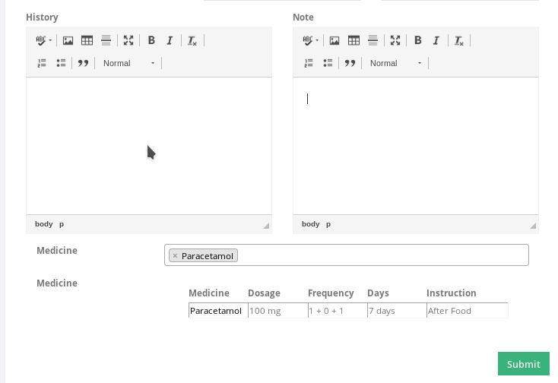Affiliates.

modules dependencies

Digital Health Access: 1.Patients

Has a tab called my consultants.

This has list of Consultants he added from consultants list

Those he chat with or Book appointment with or followed

He can view his health tools

view consultants profile

Post to forums, reply in a forum.

like and follow a post in forums

Write a review for a consultant and an affiliate.

2.consultants

He manages his patients under patients list ( Add prescription, add appointment,add data in health tools.

Answer questions in health Forum

Chat with patients and fellow consultants

3.Forum/Questions

Post by patients

Shows on front end after reciving first reply from consultants

has follow, like and reply functions

4. consultations/chats

Initiated by patients or fellow consultants by clicking on consult now button from front end or from the dashboard

5.Prescriptions history and Notes

Done by consultans for patientsaccording to the form shown earlier

patients view from their side

Health Tools

Health Vitals

Weight management

Food and nutrition

entered by consultants and viewed by patients graphically where applicable

.

Appointments

Entered by patients or consultants

view,edit or approved by consultants

8. Pakages

set pakages and associated cost by consultants

group patients based on pakages

enter services to be rendered in the pakage

generate invoice based on the packages

9.Lab

View lab Request from consultants

Add patients

enter lab results for a patient

Create lab Test categories

add individual labs

Set templates

view lab results of patients

add bils according to labs and generate invoice for patients

Budget

|  |  |
| --- | --- |
| Module | Cost |
| patients | 75$ |
| Consultants |
| Forum/questions |
|  |  |
| Consultations/chats  Prescription/History/Notes  Health Tools | 100$ |
|  |  |
| Apointment  packages | 25$ |
|  |  |
| Lab  Pharmacy  Finance | 120$ |
| Affiliate  Sms  Email | 55$ |